Project Design Phase Problem – Solution Fit Template

Date | 15 February 2025
Team ID | LTVIP2026TMIDS66228
Project Name | Advancing nutrition science through geminiai
Maximum Marks | 2 Marks

Problem – Solution Fit Template:
The Problem-Solution Fit for Advancing Nutrition Science through Gemini AI focuses on identifying real nutritional challenges faced by individuals and delivering an AI-powered solution that effectively addresses those challenges. The system provides personalized meal planning, accurate nutritional insights, and virtual coaching using Gemini AI to solve users' dietary management problems.

Purpose:
- Provide intelligent, AI-driven nutrition solutions that match the specific health goals and dietary needs of users.
- Enhance adoption by integrating a user-friendly web interface and AI-powered personalized nutrition recommendations.
- Deliver clear nutritional insights and personalized health guidance through conversational AI interactions.
- Increase user engagement by offering continuous nutrition tracking, meal planning, and real- time AI coaching.
- Analyze user dietary habits and health conditions to improve nutritional outcomes through intelligent AI-based recommendations.

Template:
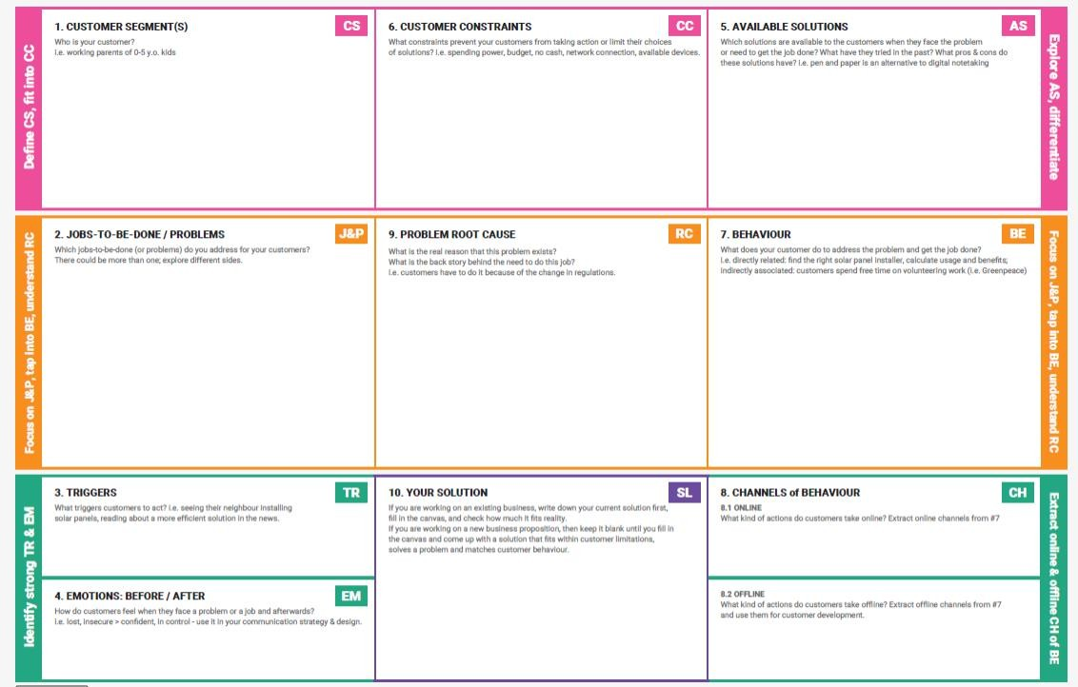
References:

- https://www.ideahackers.network/problem-solution-fit-canvas/
- https://medium.com/@epicantus/problem-solution-fit-canvas-aa3dd59cb4fe

